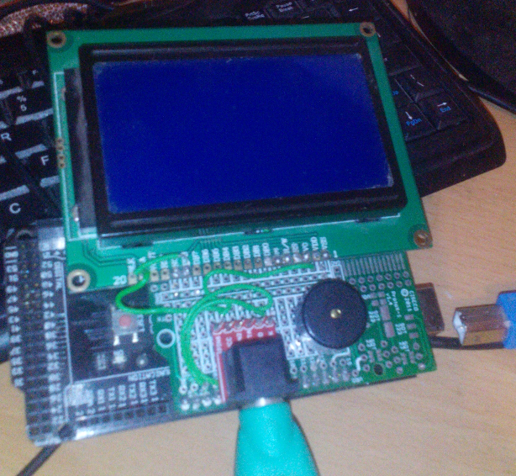**Put out : Hardware, ST7920 Driver**

This is the Mark 1 replica of the WP1 … and it seems to work, and it seems to work quickly enough.

The design is very simple. The display is an ST7920 SPI GLCD which is 128 x 64 resolution. It is connected to A0,A1 and A2 so it is bit banged rather than uses the built in SPI.

On the right, a piezo buzzer, and in the lower middle a PS/2 keyboard adaptor. You can’t buy PS/2 keyboards any more, so there’s a USB->PS/2 adaptor (which you can buy dirt cheap …..) plugged into it and an ordinary keyboard onto that. The Arduino’s power lead/programming connector is on the right, not plugged in.

The whole thing lives on a Mega 2560 board, which will probably give me about 6k – 7k of RAM when I have finished, which will be masses – most of the software will be ROM based, and the Trek program Is not that big.

The picture is rather odd, the bottom left looks like something weird is plugged in there, but its an artefact of the proto board (which is an Arduino UNO one) and the Arduino board underneath it.

Sound is not emulated yet, on either, so the next thing I will do is to code the sound interface for the real thing and the emulator, and write a better testing program than the current bodge.

The other thing I haven’t done yet is copied the Video display circuit.